Le Chatelier's Principle
AP Chemistry Notes: equilibrium

1. The Principle
Le Chatelier's principle: when a system at equilibrium is disturbed (a stress), the system shifts in the direction that partially reduces the stress, and a new equilibrium is established.
- A shift right means the forward reaction is favored: more products form, and reactants are used up.
- A shift left means the reverse reaction is favored: more reactants form, and products are used up.
- The shift reduces the stress but does not eliminate it. The new equilibrium is different from the old one.
- Every shift can be explained with Q vs K. The stress changes Q (or K), and the reaction shifts until Q = K again.

The picture over time
This graph follows H₂(g) + I₂(g) ⇌ 2HI(g) after extra HI is added. The concentrations are flat at equilibrium. The stress makes [HI] jump up, and then the system shifts left: HI falls a little and H₂ and I₂ rise until a new equilibrium is reached. Notice that [HI] ends higher than it started, and that the system never fully undoes the stress.
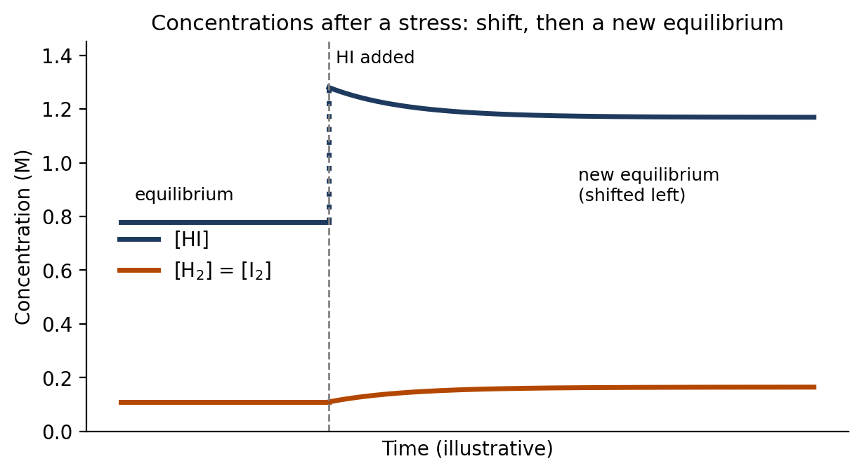

2. Types of Stress and the Shift
Stress | Shift | Why (in terms of Q and K)
Add a reactant | Right → | Q gets smaller than K
Remove a reactant | ← Left | Q gets larger than K
Add a product | ← Left | Q gets larger than K
Remove a product | Right → | Q gets smaller than K
Decrease volume (increase pressure) | Toward the side with fewer moles of gas | Q changes as concentrations increase
Increase volume (decrease pressure) | Toward the side with more moles of gas | Q changes as concentrations decrease
Increase temperature | Toward the endothermic direction (absorbs heat) | **K changes**
Decrease temperature | Toward the exothermic direction (releases heat) | **K changes**
Add a catalyst | No shift | Speeds up both directions equally
Add an inert gas (constant volume) | No shift | Concentrations of reacting gases do not change

Only a change in temperature changes the value of K. All the other stresses change Q, and the system shifts until Q = K again with the same K.

3. Changing Concentration
Adding or removing a reactant or product changes Q right away. The reaction then shifts to bring Q back to K.
- Decide whether the substance is on the reactant side or the product side.
- Adding it makes that side larger. The system shifts away from it. Removing it makes that side smaller. The system shifts toward it.
- Confirm with Q if you need to.
Solids and pure liquids do not appear in K, so adding or removing them causes no shift.
Example 1: Adding a product
N₂O₄(g) ⇌ 2NO₂(g), K_{c} = 0.36. At equilibrium [N₂O₄] = 0.040 M and [NO₂] = 0.120 M. Extra NO₂ is added so that [NO₂] = 0.220 M. Which way does the reaction shift?
- NO₂ is a product, and adding it makes the product side bigger.
- Check with Q: Q = $\frac{[NO₂]²}{[N₂O₄]}$ = $\frac{(0.220)²}{0.040}$ = $\frac{0.0484}{0.040}$ = 1.21.
- Q = 1.21 is greater than K = 0.36, so the reaction shifts left.
- [N₂O₄] increases above 0.040 M. [NO₂] decreases from 0.220 M, but it stays above 0.120 M, because the system only partly undoes the stress.
Example 2: Removing a product
N₂(g) + 3H₂(g) ⇌ 2NH₃(g). In the Haber process, NH₃ is removed as it forms. Which way does the reaction shift, and what happens to [N₂]?
- NH₃ is a product. Removing it makes the product side smaller.
- The reaction shifts right to replace it (Q becomes smaller than K).
- [N₂] and [H₂] decrease as they are used up, and more NH₃ is made. This is why removing the product improves the yield.
Example 3: Predicting every species
N₂(g) + 3H₂(g) ⇌ 2NH₃(g). More H₂ is added to a system at equilibrium. Describe what happens to [H₂], [N₂], and [NH₃].
- H₂ is a reactant, so adding it shifts the reaction right.
- [N₂] decreases (it is used up by the extra H₂).
- [NH₃] increases (more product forms).
- [H₂] jumps up when it is added, then decreases as the reaction shifts right. The final [H₂] is higher than the original but lower than right after the addition.

4. Changing Volume or Pressure
Pressure changes only matter for reactions with gases. Changing the volume of the container changes all of the gas concentrations at the same time.
- Decrease the volume (raises the pressure): the system shifts toward the side with fewer moles of gas.
- Increase the volume (lowers the pressure): the system shifts toward the side with more moles of gas.
- If both sides have the same number of moles of gas, there is no shift.
- Count only gases (g). Solids, liquids and aqueous substances are not counted.
- Add up the coefficients of the gases on the reactant side.
- Add up the coefficients of the gases on the product side.
- Compare the two totals and use the rules above.
Example 4: Fewer moles on one side
2SO₂(g) + O₂(g) ⇌ 2SO₃(g). The volume of the container is cut in half. Which way does the reaction shift?
- Reactant side: 2 + 1 = 3 moles of gas. Product side: 2 moles of gas.
- Decreasing the volume favors the side with fewer moles, which is the product side. The reaction shifts right.
- Check with Q: halving the volume doubles every concentration. Q = $\frac{[SO₃]²}{[SO₂]²[O₂]}$. The top is multiplied by 2² = 4 and the bottom by 2² × 2 = 8, so Q becomes $\frac{4}{8}$ = ½ of its old value.
- Q is now half of K, so Q < K, and the reaction shifts right. ✓
Example 5: Equal moles on both sides
H₂(g) + I₂(g) ⇌ 2HI(g). The volume of the container is decreased. Which way does the reaction shift?
- Reactant side: 1 + 1 = 2 moles of gas. Product side: 2 moles of gas.
- The totals are equal, so there is no shift.
- Check with Q: doubling every concentration multiplies the top by 2² = 4 and the bottom by 2 × 2 = 4, so Q = $\frac{4}{4}$ = 1 times its old value. Q is unchanged, so Q = K and nothing shifts. ✓
Example 6: A reaction with solids
CaCO₃(s) ⇌ CaO(s) + CO₂(g). The volume of the container is decreased. Which way does the reaction shift?
- Only gases count. The reactant side has 0 moles of gas and the product side has 1 mole of gas (CO₂).
- Decreasing the volume favors the side with fewer moles of gas, which is the reactant side.
- The reaction shifts left, and some CO₂ combines with CaO to make CaCO₃.
Adding an inert gas (such as helium) at constant volume does not change the concentrations of the reacting gases, so Q is unchanged and there is no shift.

5. Changing Temperature
Temperature is different from the other stresses because it changes the value of K. To predict the shift, treat heat as a reactant or a product in the equation.
Reaction type | Sign of ΔH | Heat is written as… | Equation form
Endothermic | positive (+) | a reactant | reactants + heat ⇌ products
Exothermic | negative (−) | a product | reactants ⇌ products + heat

- Write heat into the equation on the correct side.
- Increasing the temperature is like adding heat, so the reaction shifts away from the side with heat. Decreasing the temperature is like removing heat, so the reaction shifts toward the side with heat.
- Decide whether K increases or decreases: if the reaction shifts right, K increases. If it shifts left, K decreases.
Reaction | Increase T | Decrease T
Endothermic | Shifts right, K increases | Shifts left, K decreases
Exothermic | Shifts left, K decreases | Shifts right, K increases

Example 7: Endothermic reaction
N₂O₄(g) ⇌ 2NO₂(g), ΔH = +57 kJ. N₂O₄ is colorless and NO₂ is brown. What happens to the color when the system is heated?
- ΔH is positive, so the reaction is endothermic. Write heat as a reactant: heat + N₂O₄ ⇌ 2NO₂.
- Increasing the temperature adds heat, so the reaction shifts right.
- More NO₂ forms, so the mixture becomes darker brown. K increases.
Example 8: Exothermic reaction
N₂(g) + 3H₂(g) ⇌ 2NH₃(g), ΔH = −92 kJ. What happens to the yield of NH₃ when the temperature is increased? What happens to K?
- ΔH is negative, so the reaction is exothermic. Write heat as a product: N₂ + 3H₂ ⇌ 2NH₃ + heat.
- Increasing the temperature adds heat, so the reaction shifts left.
- The yield of NH₃ decreases, and K decreases.
Because a higher temperature also makes the reaction faster, industrial processes such as the Haber process use a compromise temperature. It is high enough for a reasonable rate, but not so high that the yield drops too much.

6. Catalysts
A catalyst lowers the activation energy for both the forward and reverse reactions equally. The system reaches equilibrium faster, but the position of equilibrium and K are not changed. A catalyst causes no shift.

Summary and Quick Reference
Stress | Effect on Q or K | Shift | Does K change?
Add reactant | Q decreases | Right → | No
Remove reactant | Q increases | ← Left | No
Add product | Q increases | ← Left | No
Remove product | Q decreases | Right → | No
Decrease volume | Depends on moles of gas | Side with fewer moles of gas | No
Increase volume | Depends on moles of gas | Side with more moles of gas | No
Increase temperature | K changes | Endothermic direction | **Yes**
Decrease temperature | K changes | Exothermic direction | **Yes**
Catalyst | None | No shift | No
Inert gas (constant volume) | None | No shift | No

Common Mistakes
- Saying a shift "undoes" the stress completely. It only reduces it.
- Adding a solid or pure liquid and predicting a shift. They are not in K, so there is no shift.
- Counting solids, liquids or aqueous substances when comparing moles of gas.
- Thinking a catalyst shifts the equilibrium. It only makes equilibrium arrive faster.
- Forgetting that temperature is the only stress that changes K.
- Predicting a pressure shift for a reaction with equal moles of gas on both sides.
- Confusing the direction after adding a substance: adding a reactant shifts right (away from it), and adding a product shifts left.

